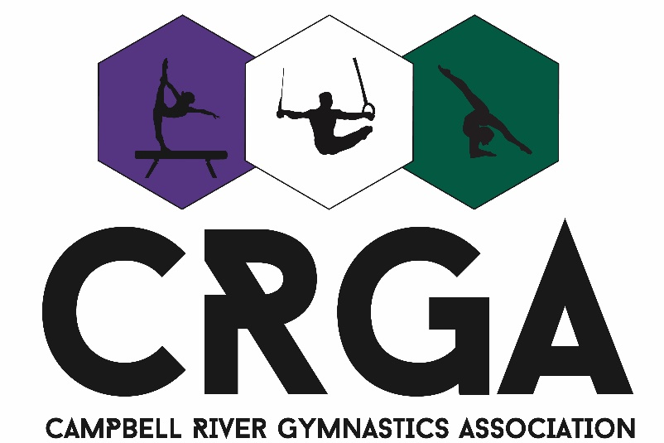

Campbell River Gymnastics Association

Parent/Athlete Handbook

Welcome to another season with our association!
Within this handbook, you will find that our expectations have been broken into two categories: Expectations within the gym and expectations at competitions.

**Please read through all topics and refer to the final page where you will find a space for both you and your child to sign an agreement stating that you have both read and understood all expectations. If you have any questions regarding these topics, please address them to our office administration.**

**Campbell River Gymnastics reserves the right to refuse service at any time, without refund, to participants and families who disregard gym guidelines and safety regulations.**

Our Vision

The Competitive Program strives to give the gymnasts the opportunity to develop a positive self image, physical strength, self-regulation, and sportsmanship. It governs teamwork, the ability to work together, set goals and achieve them and learn self-confidence that will last a lifetime. Competitive gymnasts learn to reach high, overcome difficulties and to manage fear and overcome adversity. We believe that all children have a place in this sport, and we aim to provide a safe, respectful, and positive environment for the athletes attending our program.

Within the Gym

Registration
We thank you for choosing our programs for your child to partake in. Part of the beginning process is our registration and payments.
In accordance with Gymnastics BC, all participants are required to have a registration form and an Assumption of Risk waiver signed and submitted. Without these forms, athletes will not be permitted onto the floor, and not able to participate in their class. Along with this, all monthly payments must be kept up to date. If you are behind in payments, our office administration will call to inform you; however, if we do not receive payment shortly thereafter, your child may not be able to participate until the owing balance has been paid or alternative payment arrangements have been discussed. Pre registration is recommended to avoid any confusion.

Parent/Athlete Conduct

All parents and athletes that join our program will be held under the same general scope of conduct. At Campbell River Gymnastics, we encourage a supportive atmosphere and experience for all those who partake. Positivity and politeness towards other athletes and families is always required. Maintaining a positive and encouraging energy towards your child regarding their gymnastics will likely result in higher levels of motivation and demonstrate that they must reflect this behaviour towards their teammates and their families.

Attendance and Attire
All athletes must attend their training sessions ready to participate. This begins with what they bring to wear. For girls, a training suit or leotard, with or without shorts, is recommended. A one-piece bathing suit will also do, but at no time is it appropriate to wear anything that exposes the mid section or the chest. For boys, t-shirts and shorts are recommended, but nothing baggy! There must be NO zippers, buttons, or buckles on any clothing for all! If your child does not have appropriate clothing, they will be asked to either change, or they will be given extra clothing that is kept in our office.
To reach the highest chances for success during each class, it is important to always be on time to begin the warm-up. During this portion of the class, your child is working directly with coaches to prepare their bodies for the day and the skills they will be training. A body that is not properly warmed up and stretched is more likely to experience soreness, pains, and possible injury. To avoid this, having scheduled warm-ups, conditioning, and stretching is the easiest way to assure success and progress. There are often cool down activities that are done at the end of class – when the body is at its warmest. We encourage that you do not remove your child from class early unless there are unavoidable circumstances. If you must leave, or if you anticipate that you will be late, please communicate this with your coach. If you are unable to do so, please call our office administration ahead of time to have the message relayed.
All coaches take attendance, and if it is noted that there is consistent lateness or absences, your coach may choose to have a meeting regarding this. If there are unavoidable circumstances (ie. Work schedules, family emergency etc.), please express this before the start of the season or before a class. An attendance rate of 75% each month must be maintained in order to remain part of our competitive program. If there is an upcoming competition, each athlete must attend equal training days to equal prior absent days. An example of this would be 1 week away = 1 week back, 2 weeks away = 2 weeks back, etc. Failure to do so will result in them not being able to compete. Missing the last practice before a competition is not recommended, as it puts too many days in between practice and competition and can result in soreness, injury, or lack of necessary information that you coach may have for the team.
It is important to note the importance of academics and sport. Maintaining acceptable grades in school and balancing that with training is important and both must be treated equally. Please communicate with your coach if your child is falling behind in class and needs to take a day off to catch themselves up.
If you are anticipating being away for a long period of time, remember that communication with your coach is key! These absences will be noted as being understood by your coach and our office staff.

Observing a Class
While some organizations do not permit their parents to watch a training, that is not the case for our programs. With that being said, we would like to emphasise some of the pros and cons of observing a class.
For many athletes, having a parent or family member stay for an entire training session can have a negative effect on their performance. At no time is it ever appropriate for a parent to come onto the floor, nor is it appropriate to communicate to your child while they are participating. Yelling to your child from off the floor is distracting, not only for them, but for others in the class, and it is important to remember that some children may be embarrassed by this in front of their peers. Building independence will have a positive long-term affect on their training and their day to day lives.
All competitive coaching staff are trained and have numerous years of experience in the sport. Giving your child directions from off the floor can be contradictory to what their coach would like them to do and can be detrimental to their progress, attention, and safety. Any form of disrespect towards coaches or other classmates is not tolerated.
In some instances, it is recommended that a parent be present during a training session. If your child has trouble focusing or is reluctant to participate, the support of a parent is appreciated by all. When making the decision to stay or to leave a training session, it is always advised to take into consideration whether your presence or absence will be a benefit to your child or not.

Snacks
As with most sports, success in gymnastics requires a nutritious and fulfilling diet. Most classes are long enough that athletes will have a short break for a snack. We highly recommend that you send your child to gymnastics with healthy options and avoid ``junk foods``. From time to time a treat is okay, but this should not be a regular occurrence. At the end of the season, or over holidays, there may be class celebrations, and those are acceptable reasons to have your child bring a treat to gymnastics!

Grievances
From time to time, there may be points where addressing questions or concerns are necessary. If you have a topic that you wish to discuss, there is an order of who you should consult first:

The Coach:
Coaches have your children for the entirety of their training time in the gym. If there is anything that needs to be addressed, this is who you must come to first. Your childs’ coach will have the most information to give you because they are aware of all the class proceedings. If you have had a meeting with the coach and still feel that a given situation is not resolved, then you may continue to the next step, which is to consult the Head Coach, who is also the program director.

Head Coach:
Having a meeting with the Head Coach of our program may result in having the coach present in order to express any concerns and bring everyone to an agreement on ways to resolve them. This is often not necessary if the first step has been taken. If there is still a level of unsatisfaction, then the final step will be to consult our office administration.

Office Administration:
Any further concerns should be addressed to the Office Administration if it is regarding our facility as a whole, and not in any particular instance regarding class proceedings. This can often be managed quickly and will only require a brief discussion.

At Competition

Payments and Sign Up
Campbell River Gymnastics protocol for competitions is that we must receive payment at the time of sign up. This ensures that the hosting club for any competition receives adequate payments for the use of their venue. If you have signed up and paid but have to remove your child from the competition for any reason, a doctors’ note will be required for any possible refund once it is past the withdrawal deadline.

Attire – Boys and Girls
Before departing for a competition, it is important to have all the proper attire at least two weeks prior. For girls, they will require their competitive suit and scrunchie, along with their Campbell River Gymnastics yoga jacket and black non print leggings. Hair must be slicked back in a way that it will not fall in their face and will not touch the equipment during a routine. For boys, they will require the competitive singlet, a pair of black competitive shorts, a pair of white longs, as well as white socks.
Occasionally gymnasts will have a small bag that they bring with them onto the floor at a competition, and this should carry their grips or tiger paws (if they have a pair), floor routine music, as well as a small water bottle and small snack to avoid having to leave the floor while competition is underway.

Arriving at the location
Approaching competition day, please be sure that you are aware of the exact location of the venue. It is important to arrive ten to fifteen minutes before your warm-up time to ensure a relaxed transition onto the floor for your child. Being late can result in anxiety for some, and after a certain amount of time has passed, they may not be allowed to participate once a competition has started.

Conduct at Competitions
Equal parts exciting and nerve-racking, competitions are the place to see your children put their hard work into action. Cheering for your child is encouraged, but only when it is appropriate. During your time observing, it is important to remember that there is to be no flash photography. This can distract athletes during their routines. Being respectful of all competitors is required.
At no time should a parent come onto the floor. If there was a medical emergency, your coach or another official would direct you safely around the other competitors.
At no time should a parent attempt to communicate with Judges or other officials. If there is a score that you may not agree with, be assured that your coach may have a reasonable explanation and that they have already discussed it with the Judges if they find it necessary.
Athletes must remain on the floor until all athletes are done competing. This is out of respect for those who may not yet be finished and having a crowd of moving people may be very distracting.
All athletes must attend the Award Ceremonies following their session, regardless of receiving an award or not. This is to promote a positive teambuilding experience by showing support for each other. Removing a child from the Ceremony does not allow them to go through character building experiences with their teammates, as winning 100% of the time does not always happen. Showing good sportsmanship towards teammates and other competitors reflects positive values and can be an essential part of their individual growth.

Conclusion
Please ensure that you have not only read this document yourself, but that you have also read it with your child participating in our program. Have them initial down below, as well as leave your own signature. In doing so, it is concluded that the above expectations have been read and are understood.
If you have any further questions, don’t hesitate to contact our office.

Parent Signature:

Athlete Initials:

